03/17/2020A World Conflict Playlist - Interwar Dictators
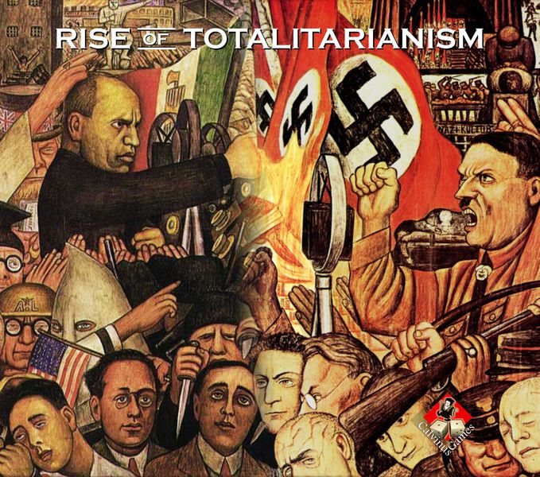
Essential Question: What motivated the nations of Europe to form alliances?
Objective: compare the political and economic differences between fascism and communism on a t-chart
Standards: 7.H.2.1
Slide #s: 30 -50
Do Now:
- In your own words, type the definitions for the following words on a new Google Drive sheet and attach them to today’s lesson:
  - Totalitarianism
  - Fascism
  - Purge
  - Nazism
  - Axis Powers
  - Appeasement
- It is important you reword the definition in your voice without changing the meaning or copying/ pasting from the internet
- Each person’s definitions should be unique
- This activity should take no more than 10 minutes

Today in History Fact: 1942 -The Nazis begin deporting Jews to the Belsen camp

Activity #1
- Instruction - Interwar Introduction to the Rise of Totalitarian Dictators

Activity #2
- Newsela - Rise of Totalitarian Dictators
  - Click on the link in your Google Classroom
  - Read the article
  - Answer the comprehension questions

Activity #3
- Watch the Flocabulary video “Between the Wars” https://youtu.be/c0Lo33jm7NI
- Then answer the read and response questions on the Google Form in your located in Google Classroom

Activity #4
- Create a t-chart below to show the difference between communism and fascism

Homework:
- Make sure to complete all Google Classroom enrichment activities added for you
- Review at least 15 minutes

