03/16/2020A World Conflict Playlist - From Boom to Bust
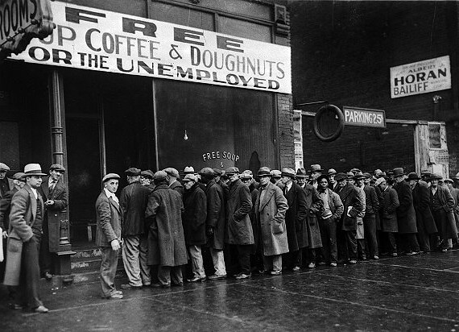
Essential Question: How can a country’s economic problems affect the global economy?
Objective: explain how the economic crisis contributed to the growth of various political and economic movements
Standards: 7.E.1.1, 7.H.2.1, 7.C.1.1
Slide #s: 20-30
Do Now:
- Log into your Quizlet account for the Interwar vocabulary words https://quizlet.com/_69wx81?x=1jqt&i=1gbbbt . In your own words (no copying and pasting), re-define the following words in the box below or on paper (send a picture to neukisha.motsinger@capitolencoreacademy.org:
  - Economic depression
  - The Five-Year Plan
  - Tariff
  - Black Tuesday
  - Inflation

Today in History Fact: 1833 -Susan Hayhurst becomes the first woman to graduate from a pharmacy college

Activity #1
- Instruction - Interwar Global Great Depression

Activity #2
- The Origins of the Great Depression (GRADED)
  - Click on the Actively Learn link in your Google Classroom /Activities
    - Sign in with the quick click Google
  - Read the “Origins of the Great Depression” article
    - Annotate
    - Highlight unfamiliar terms
    - Answer the comprehension questions

Activity #3
- Digital Escape Room
  - How well do you remember the information you learned today
  - Explore the https://sites.google.com/view/loqlrngreatdepression/home?authuser=0

Exit Ticket:

Homework:
- Make sure to complete all Google Classroom enrichment activities added for you
- Review at least 15 minutes

